Cairo University  
Faculty of Computers and Information



**CS251**

**Software Engineering I**

Computek

Software Design

Mahmoud Sami

Mahmoud Amin

Mustafa Mohamed

Dec-2016

Contents

Team 3

Document Purpose and Audience 3

System Models 4

I. Class diagrams 4

II. Sequence diagrams 8

Class - Sequence Usage Table 9

Github URL………………………………………………………………………………………………………………………………………………….15

# Team

|  |  |  |  |
| --- | --- | --- | --- |
| **ID** | **Name** | **Email** | **Mobile** |
| 20140247 | Mahmoud Sami | [m.sami11111995@gmail.com](mailto:m.sami11111995@gmail.com) | 01205787165 |
| 20140271 | Mustafa Mohamed | [Mustafa_xd23@yahoo.com](mailto:Mustafa_xd23@yahoo.com) | 01280969556 |
| 20140255 | Mahmoud Amin | Mahmoudamin502@gmail.com | 01026510565 |

# Document Purpose and Audience

***Audience***

Our audience are Project manager, CEO and developers are included in our audience and anyone who have new ideas to enhance this project.

***Purpose***

This document will illustrate our efforts to develop new websites, it will also abstract the functionalities of these websites and how it will help others to learn more about specific topics, this document is purposed to stakeholders, developers and anyone interested in this project, throughout this document we will have a brief view about some definitions, requirements and use cases of all functionalities of this project.

# System Models

## I. Class diagrams

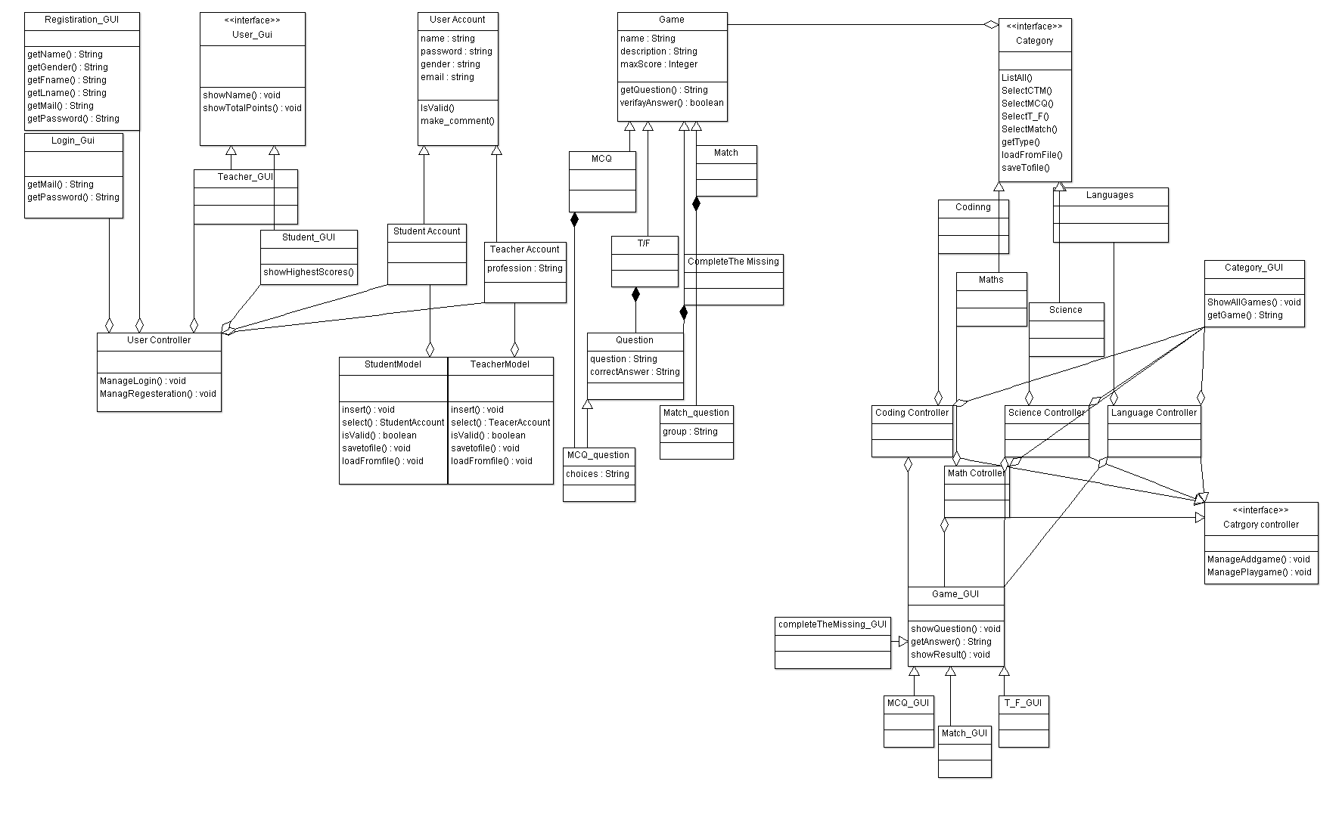

| **Class ID** | **Class Name** | **Description & Responsibility** |
| --- | --- | --- |
| RGUI | Registeration_GUI | Responsible for data that the user inputs in Registration process |
| LG110 | Login_GUI | Contains the mail and password that are needed for log in operations |
| UG33 | User_GUI | Created to show the user name and the total points he gains each time. |
| TG31 | Teacher_GUI | Responsible for Teacher screen which contains all operations that teacher can do like add a game. |
| SG30 | Student_GUI | Responsible for Teacher screen which contains all operations that student can do like play a game. |
| UCTRL90 | User controller | Responsible for managing the registration and login operations. |
| SM22 | Student Model | Created to insert and select student and check the validation besides load and save with files |
| TM11 | Teacher Model | Created to insert and select teacher and check the validation besides load and save with files |
| MC2Q | MCQ_question | Contains the question related to MCQ game |
| MQ01 | Match_question | Contains the question related to Match game |
| CTGUI27 | Category_GUI | Shows all games and get game. |
| Q00 | Question | Created to contain the question and the correct answer. |
| GM2000 | Game_GUI | Responsible for showing Questions and get answers and showing the results. |
| CTG_ctrl | Category_Controlle | Manage adding and playing games. |
| TF1 | T_F_GUI | Show the true and false game on GUI |
| MCQ2 | MCQ_GUI | Show the MCQ game on GUI |
| MTch3 | Match_GUI | Show the Match game on GUI |
| CMT4 | completeTheMissing_GUI | Show complete The Missing game on GUI |
| CodeCtrl1 | Coding Controller | Responsible for controlling the coding category and manage playing and adding game in this category |
| MathCtrl2 | Math Controller | Responsible for controlling the math category and manage playing and adding game in this category |
| LangCtrl3 | Language Controller | Responsible for controlling the language category and manage playing and adding game in this category |
| ScienceCtrl4 | Science Controller | Responsible for controlling the science category and manage playing and adding game in this category |
| UA101 | User account | Holds user’s data |
| TA102 | Teacher Account | Holds teacher’s data and responsible for inserting a new teacher in the database. |
| SA103 | Student Account | Holds student’s data and responsible for inserting a new student in the database. |
| I104 | Interface<<interface>> | Shows a friendly interface form for the user. |
| G108 | Game | Holds the games data and select, insert from database. |
| MCQ109 | MCQ | A game type. |
| T/F110 | T/F | A game type. |
| M111 | Match | A game type. |
| CM112 | Complete the missing | A game type. |
| C113 | Category<<interface>> | Holds all category data & insert, select from database. |
| SC114 | Science | A category type. |
| M115 | Math | A category type. |
| LAN116 | Language | A category type. |
| C117 | Coding | A category type. |

### 

### 

## 

## II. Sequence diagrams

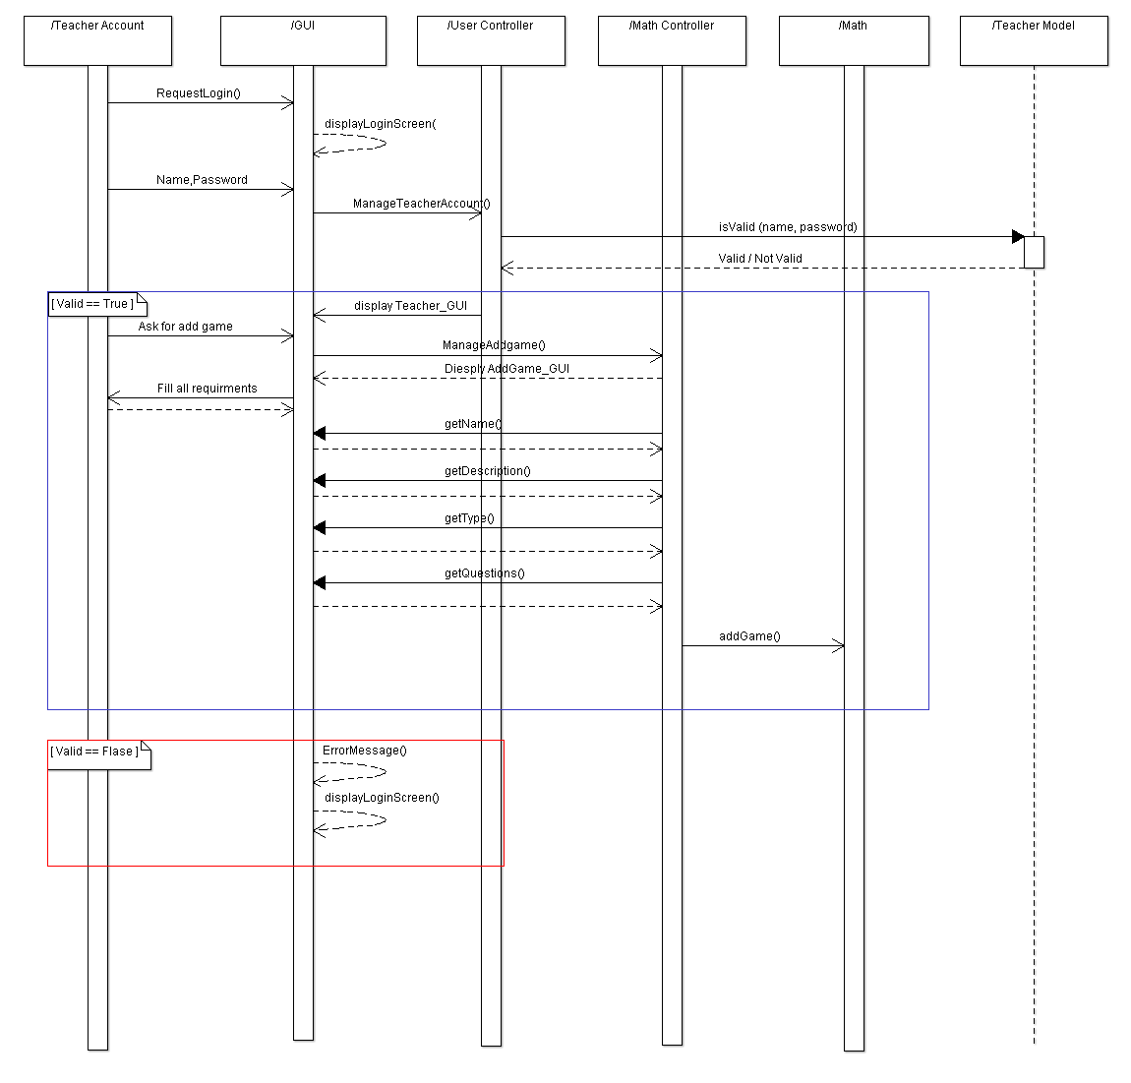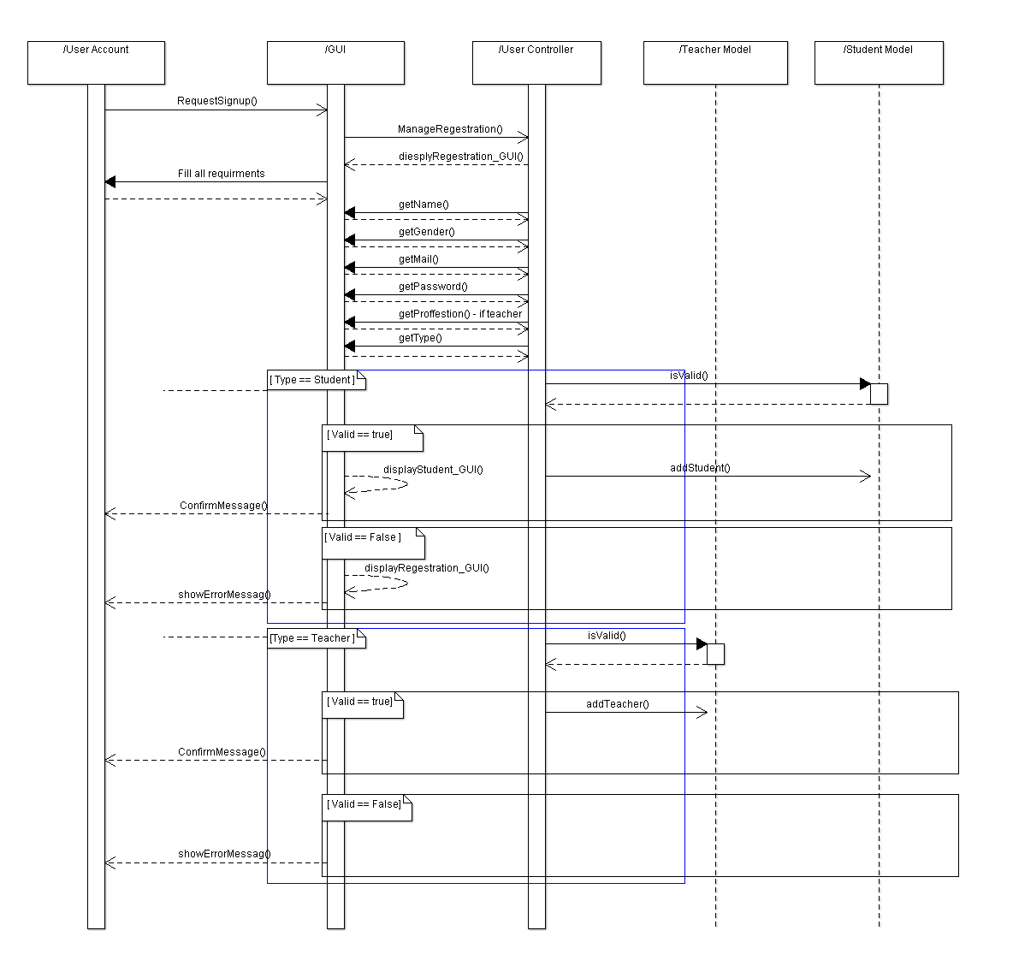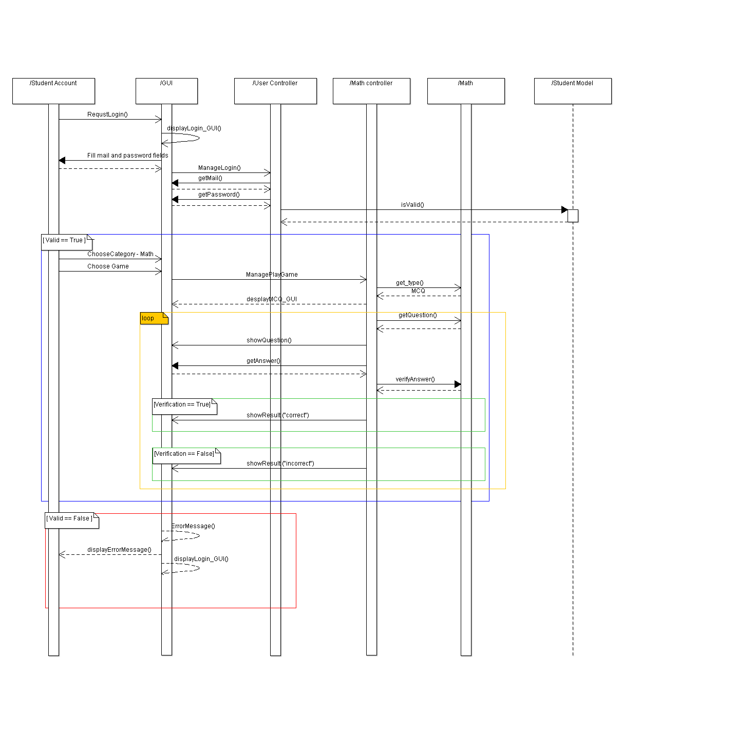

### Class - Sequence Usage Table

|  |  |  |
| --- | --- | --- |
| **Class Name** | **Sequence Diagrams** | **Overall used methods** |
| Registration_GUI | Register , add a game , play a game | getFname()  getLname()  getMail()  getPassword()  getGender()  getName() |
| Login_GUI | Add a game, play a game | getMail()  getPassword() |
| User_GUI | Add a game, play a game | showName()  showTotalPoints() |
| Teacher_GUI | Register, Add a game, play a game | manageLogin()  ManageRegisteration()  showName()  showTotalPoints() |
| Student_GUI | Register, Add a game, play a game | manageLogin()  ManageRegisteration()  showName()  showTotalPoints()  showHigherstScores() |
| StudentAccount | Register, Add a game, play a game | Insert()  Select()  isValid()  SaveToFile()  LoadFromFile() |
| TeacherAccount | Register, Add a game, play a game | Insert()  Select()  isValid()  SaveToFile()  LoadFromFile() |
| StudentModel | Register, Add a game, play a game | Insert()  Select()  isValid()  SaveToFile()  LoadFromFile() |
| TeacherModel | Register, Add a game, play a game | Insert()  Select()  isValid()  SaveToFile()  LoadFromFile() |
| Game | Register, Add a game, play a game | getQuestion()  VerifyAnswer()  ListAll()  SelectMCQ()  SelectCTM()  SelectT_F()  SelectMatch()  getType()  LoadFromFile()  SaveToFile() |
| MCQ | Register, Add a game, play a game | getQuestion()  VerifyAnswer()  ListAll()  SelectMCQ()  SelectCTM()  SelectT_F()  SelectMatch()  getType()  LoadFromFile()  SaveToFile() |
| T/F | Register, Add a game, play a game | getQuestion()  VerifyAnswer()  ListAll()  SelectMCQ()  SelectCTM()  SelectT_F()  SelectMatch()  getType()  LoadFromFile()  SaveToFile() |
| completeTheMissing | Register, Add a game, play a game | getQuestion()  VerifyAnswer()  ListAll()  SelectMCQ()  SelectCTM()  SelectT_F()  SelectMatch()  getType()  LoadFromFile()  SaveToFile() |
| Match | Register, Add a game, play a game | getQuestion()  VerifyAnswer()  ListAll()  SelectMCQ()  SelectCTM()  SelectT_F()  SelectMatch()  getType()  LoadFromFile()  SaveToFile() |
| Coding | Register, Add a game, play a game | ListAll()  SelectMCQ()  SelectCTM()  SelectT_F()  SelectMatch()  getType()  LoadFromFile()  SaveToFile() |
| Language | Register, Add a game, play a game | ListAll()  SelectMCQ()  SelectCTM()  SelectT_F()  SelectMatch()  getType()  LoadFromFile()  SaveToFile() |
| Math | Register, Add a game, play a game | ListAll()  SelectMCQ()  SelectCTM()  SelectT_F()  SelectMatch()  getType()  LoadFromFile()  SaveToFile() |
| Science | Register, Add a game, play a game | ListAll()  SelectMCQ()  SelectCTM()  SelectT_F()  SelectMatch()  getType()  LoadFromFile()  SaveToFile() |
| Category_GUI | Register, Add a game, play a game | showAllGames()  getGame() |
| Category_Controller | Register, Add a game, play a game | manageAddGame()  managaPlayGame() |
| Coding_Controller | Register, Add a game, play a game | manageAddGame()  managaPlayGame() |
| Math_Controller | Register, Add a game, play a game | manageAddGame()  managaPlayGame() |
| Language_Controller | Register, Add a game, play a game | manageAddGame()  managaPlayGame() |
| Science_Controller | Register, Add a game, play a game | manageAddGame()  managaPlayGame() |
| Game_GUI | Register, Add a game, play a game | manageAddGame()  managaPlayGame()  ShowQuestions()  getAnswer()  ShowResult() |
| completeTheMissing_GUI | Register, Add a game, play a game | ShowQuestions()  getAnswer()  ShowResult() |
| T_F_GUI | Register, Add a game, play a game | ShowQuestions()  getAnswer()  ShowResult() |
| MCQ_GUI | Register, Add a game, play a game | ShowQuestions()  getAnswer()  ShowResult() |
| Match_GUI | Register, Add a game, play a game | ShowQuestions()  getAnswer()  ShowResult() |
| Question | Register, Add a game, play a game | getQuestion()  VerifyAnswer() |
| MCQ_Question | Register, Add a game, play a game | getQuestion()  VerifyAnswer() |
| Match_Question | Register, Add a game, play a game | getQuestion()  VerifyAnswer() |
|  |  |  |
|  |  |  |
|  |  |  |
|  |  |  |

**Github URL:**

<https://github.com/MahSmai/Software.git>